INSTRUCTIONS
- For efficiency, we will just use this Word Doc as the primary way of presenting the content
- Structure remains the same as before:
  - Investigation
  - Analysis
  - Report
  - Case Questions
- Follow existing structure/layout and just replace content
- In Investigation and Case Questions, draggable elements are highlighted in yellow; in Investigation, they are also commented – comments are the data labels
- In Case Questions, some question requires calculator, others don’t – these are specified in the question label at the top
- For Analysis, after each question, the answer is saved – label is whatever is in the comments
- For simplicity, we tried to minimize visuals in the Investigation section; instead, we just use tables – our tables are plain, but it would be great if the real thing had banded rows + thicker header border like what we currently have:
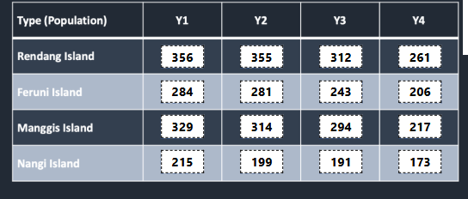

SIMULATION #4
Investigation
You are a conservationist assigned to the Mistyvale Forest Reserve, once famed for its Fallow Deer herds but now struggling after a disease ravaged the population. The overall herd size has declined considerably, with females being particularly impacted. As a result, the ability of the herd to rebuild naturally through reproduction is reduced.
To restore the deer population, your team plans to introduce new female deer from other regions.

Determine the best time to introduce the new female Fallow Deer to the Highwood and Redwood sub-areas to maximize herd population after a year.

Study Information
Winter, which lasts 3 months and is particularly harsh in Mistyvale, is fast approaching. Mating season occurs in Spring, and Fallow Deer are known to be very selective when choosing a mate. Periods of bonding is usually required before mating occurs. As a result, your team is considering 2 options:
Option 1:
Add 60 female deer to each sub-area right as winter starts (Month 1) to allow for more bonding time, but a lower chance of surviving the winter months.
Option 2:
Add 60 female deer to each sub-area right as spring starts (Month 4) to avoid death during winter months, but reduced bonding time.

The following represents the expected mortality of Fallow Deer due to the harsh winter:
Exhibit 1: Mortality of Fallow Deer due to the Winter
Winter Month | Mortality (out of population at start of month)
1 | 1 out of 6
2 | 1 out of 10
3 | 1 out of 10

The mortality rate will apply equally to male and female deer.
In addition to winter-related deaths, Fallow deer are also hunted by Frostfang Wolves. On average, Frostfang Wolves have a kill rate (deer per wolf per month) of 0.4 during non-winter months. During winter months, this increases by 50%. Male and female Fallow Deer are hunted proportionately by the Frostfang Wolves.
Assume that there are no other expected causes of death beyond those outlined above.
Field teams have surveyed each sub-area in Mistyvale to provide the following snapshot on Fallow Deer and Frostfang Wolf populations:
Exhibit 2: Fallow Deer & Frostfang Wolf Counts (Month 0)
Sub-area | Male Fallow Deer (Start of year) | Female Fallow Deer (Start of year) | Frostfang Wolf (Start of year)
Highwood | 105 | 40 | 2
Redwood | 120 | 35 | 3
Pinecliff | 105 | 45 | 4
Marshfield | 110 | 50 | 3

Fallow Deer typically breed in mid spring (Months 5), with a gestation period of about four months. The fawn (baby deer) is not expected to have higher mortality than adults due to Frostfang Wolves.
If the additional Fallow Deer were added during Winter, then 80% of all surviving adult females (both existing and new) will breed. If bonding was limited, only 20% of all surviving adult females (both existing and new) will breed. Each successful breeding results in 1 fawn.

Analysis
Question 1:
Assuming new Fallow Deer are not added during winter, what is the estimated total population in the Highwood and Redwood sub-areas after the 3 winter months? Round up your final answer to the closest integer.
Estimated total population = 194

Question 2:
If Fallow Deer are added during winter, what is the estimated total population in the Highwood and Redwood sub-areas after the 3 winter months? Round up your final answer to the closest integer.
Estimated total population = 275

Question 3:
What is the estimated total Fallow Deer population in the Highwood and Redwood sub-areas at the end of year 1 under both proposals? Round up your final answer to the closest integer; use rounded up numbers from the previous questions.
Add deer during winter = 361
Add deer during spring = 330

Question 4:
What is the percentage change in total Fallow Deer population across the Highwood and Redwood sub-areas after 1 year under both proposals? Please round your answer to the closest 1 decimal point.
Add deer during winter = 20.3%
Add deer during spring = 10%

Report
Part 1:
If the additional female deer are added during winter, the Fallow Deer population (A) [WILL / WON’T] experience population growth 1 year from now. The population will grow to (B) [ADD NUMBER: 361], which is equal to a (C) [ADD NUMBER: 20.3]% change.
If the additional female deer are added in Spring, the Fallow Deer population (D) [WILL / WON’T] experience population growth 1 year from now. The population will grow to (E) [ADD NUMBER: 330], which is equal to a (F) [ADD NUMBER: 10]% change.

Part 2:
Select the best graph to visualize the evolution of Fallow Deer population under the 2 scenarios across 3 points of time: before winter, after winter, and end of Year 1.
BAR
LINE
PIE

Part 3:
Add the relevant information to show the evolution of Fallow Deer population under the 2 scenarios across 3 points of time: before winter, after winter, and end of Year 1.
 | Before winter | After winter | End of Year 1
Adding deer during winter
Adding deer in spring

Cases
Case 1 [with Calculator]
A research team has been studying the territory growth of Arctic Wolf packs in the Mistyvale Forest Reserve over several years. Below is a table documenting their territory over four years (in km²).
Arctic Wolf Pack | Y1 | Y2 | Y3 | Y4
A | 392 | 410 | 399 | 462
B | 175 | 174 | 193 | 205
C | 598 | 584 | 732 | 752
D | 478 | 512 | 503 | 712

Question:
Which year had the largest increase in wolf pack territory compared to the previous year, and what was the percentage of that increase?

Answer:
[DROP DOWN MENU – Year 2/Year 3/Year 4] increased by [INPUT NUMBER]% from the previous year.

Case 2
A wildlife research team is studying five different bird populations across four different sub-areas within the Mistyvale Forest Reserve. These bird species are territorial and do not move between sub-areas.
Question:
What could be the best graph type to visualize how individual bird populations compare against each other within and between sub-areas.

Answer:
- Individual pie charts for each sub-area.
- Line graph showing species populations with each line representing a bird species.
- Mekko (Marimekko) chart with width representing total population by sub-area and height representing species composition.
- Simple bar chart with each bar representing population of one species in one sub-area.

Case 3
Ecologists tracked bee colony health across the Mistyvale Forest Reserve. For each sub-area, they recorded the number of active colonies and the average honey yield per colony in each season.
Sub-area | Spring Colonies | Spring Yield (kg) | Summer Colonies | Summer Yield (kg)
Highwood | 120 | 18 | 135 | 16
Redwood | 95 | 22 | 100 | 21
Pinecliff | 140 | 15 | 150 | 14
Marshfield | 110 | 20 | 108 | 19

Question:
Which of the following statements are supported by the data? You may select more than one.

Answer:
- Sub-areas with more bee colonies tend to have lower average honey yield per colony.
- Increase in number of bee colonies between seasons always reduce yield per colony, and vice-versa.
- Marshfield experienced a decline in overall honey production from Spring to Summer.
- Pinecliff is the most productive bee habitat among the four reserves.

Case 4 [with Calculator]
Below is a table documenting how land in the Mistyvale Forest Reserve is allocated.
Land Allocation | % of Total Land
Forest | 50
Flatlands | 20
Mountains | 13
Lakes / Rivers | 7
Fjords | 6
Public Amenities (e.g., roads, camp grounds) | 4

Question:
The governing body of the Reserve would like to use Flatlands to increase existing Forest coverage by 4% through replanting. In addition, some Flatlands will also be used to increase Public Amenities space by 25%. Once these initiatives are completed, what would be the ratio of flatlands to mountains? Please round your answer to the nearest 1 decimal point.
Answer:
Ratio = [INPUT NUMBER]

Case 5 [with Calculator]
Ecologists are studying the number of Spotted Deer fawns that survive to their first year in the Mistyvale Forest Reserve. The following shows their collected data:
Year (n) | Fawns born (F) | Predator Density (p) | Vegetation Density (v) | Harsh Winter (w) | Surviving Fawns (S)
1 | 800 | 1 | 1 | 0 | 560
2 | 800 | 2 | 1 | 1 | 410
3 | 400 | 1.5 | 1.5 | 1 | 230
4 | 960 | 1.5 | 1 | 0 | 622

Question:
Which formula best describes the relationship shown in the data?

Answer:
- S = F × (p/v) ​− 50w
- S = 0.7F − 100(p−1) + 100(v−1) − 50w
- S = 0.6F + 50v − 100p − 50w
- S = F − 200p + 200v − 50w

Case 6
Researchers have been studying the territorial behavior of Arctic Foxes in the Mistyvale Forest Reserve. They have broken down the Reserve into quadrants and mapped out the Fox population density (i.e., animals per quadrant) in the histogram below:
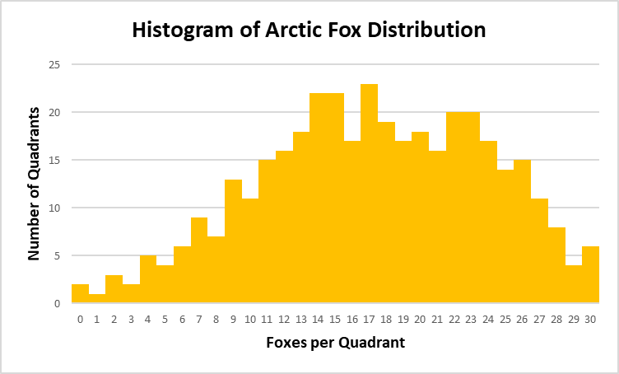

Question:
Please summarize the graph by identifying the mean, median, and mode of Foxes per quadrant.
Answer:
Mean = [DROP DOWN MENU – <15/=15/>15]
Median = [DROP DOWN MENU – <15/=15/>15]
Mode = [DROP DOWN MENU – <15/=15/>15]

